Kaley Lavery
CS-340 Client/Server Development
14 December 2025
Professor Liwanag
Assignment: 7-2 Project Two Submission
This project completes the full-stack development of a client/server web application dashboard for Grazioso Salvare, an international search-and-rescue animal training organization. The dashboard allows users to interact with data from the Austin Animal Center Outcomes dataset in order to identify dogs that meet specific rescue training criteria.
The application follows the Model–View–Controller (MVC) design pattern:
- Model: MongoDB database containing animal records
- View: Dash dashboard with interactive tables, charts, and maps
- Controller: Python CRUD module that processes user inputs and database queries
The goal of this project is to provide a user-friendly, interactive dashboard that allows filtering, visualization, and geographic analysis of animal data.
Required Functionality
The dashboard meets all required project specifications, including:

- Interactive filter options for rescue types
- Dynamic data table that updates based on selected filters
- A geolocation map that updates based on selected table rows
- A second data visualization (breed frequency chart)
- Grazioso Salvare logo and a unique identifier
- Open-source, reusable code structure
Dashboard Screenshots & Functionality Verification
1. Initial Dashboard State (Reset / Show All)
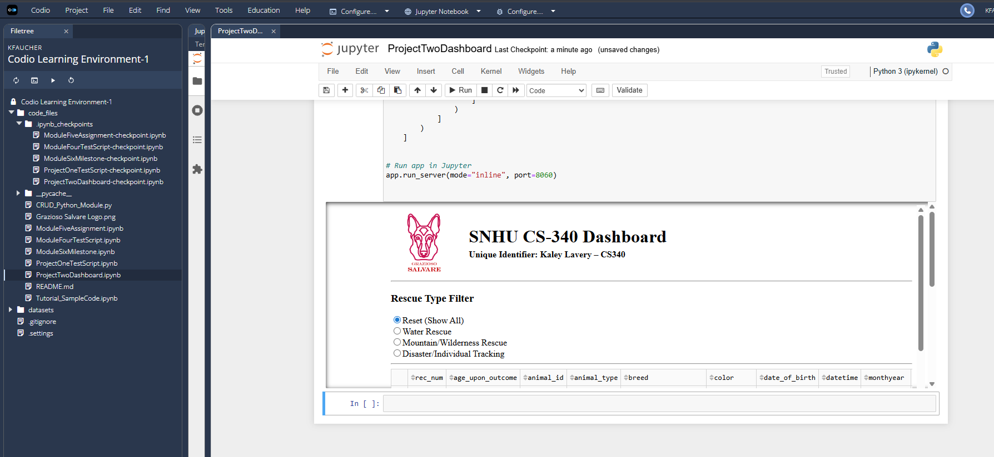
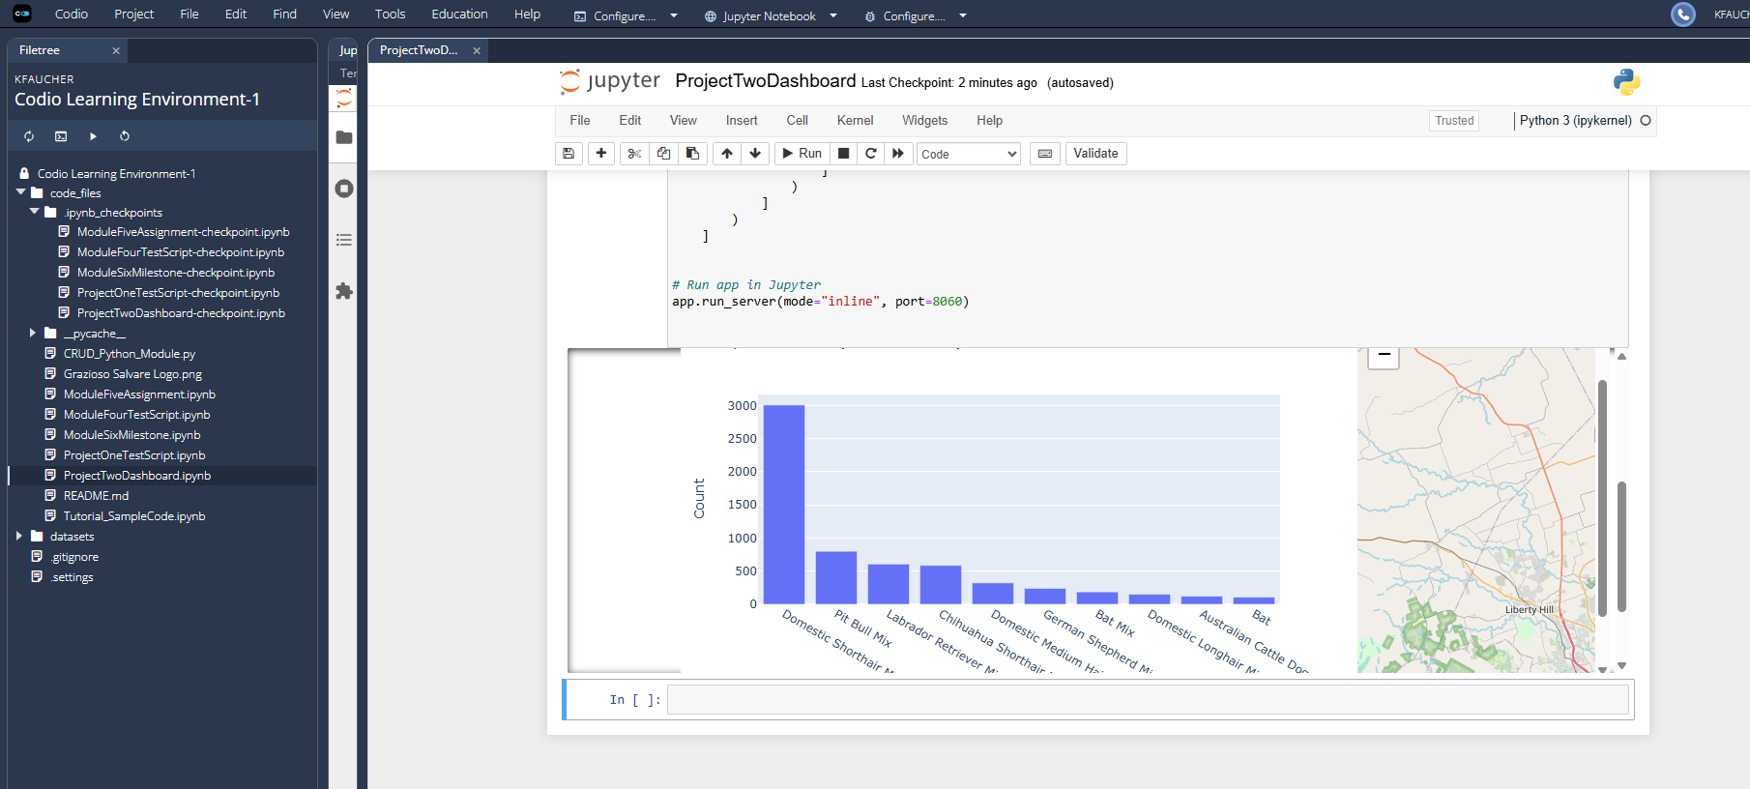
This screenshot shows the default dashboard state with no filters applied. All animal records are displayed in the data table, the breed chart reflects the full dataset, and the geolocation map displays the selected animal’s location. This state confirms that the dashboard loads correctly and retrieves all data from MongoDB.
2. Water Rescue Filter Applied
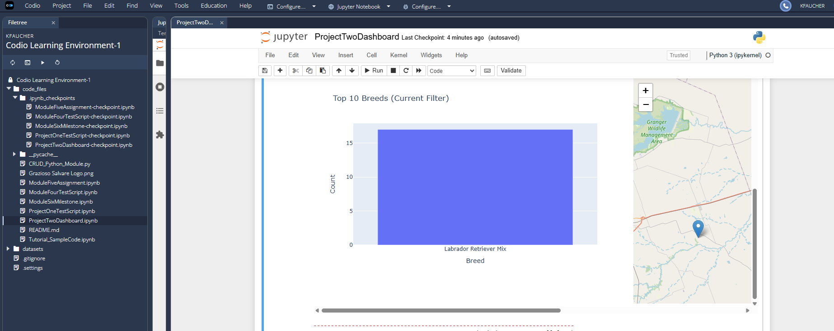
This screenshot demonstrates the Water Rescue filter functionality. When selected, the dashboard updates to display only animals that meet the Water Rescue criteria. The data table, breed chart, and geolocation map all dynamically update based on the filtered dataset.
3. Mountain / Wilderness Rescue Filter Applied
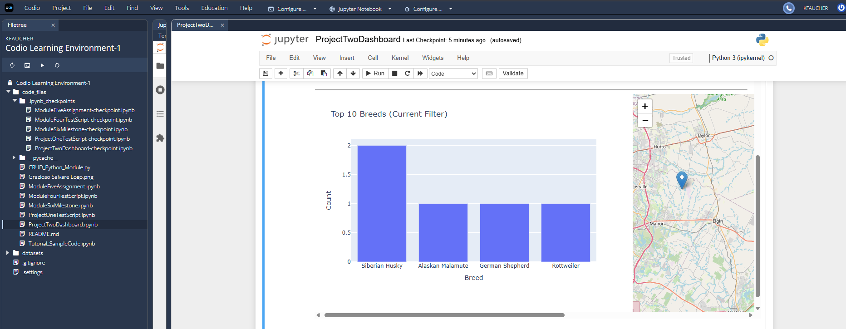
This screenshot shows the Mountain or Wilderness Rescue filter in use. The dashboard successfully filters animals based on the defined rescue profile, and all dashboard components respond accordingly. This confirms correct integration between the interactive controls and the MongoDB queries.
4. Disaster / Individual Tracking Filter Applied
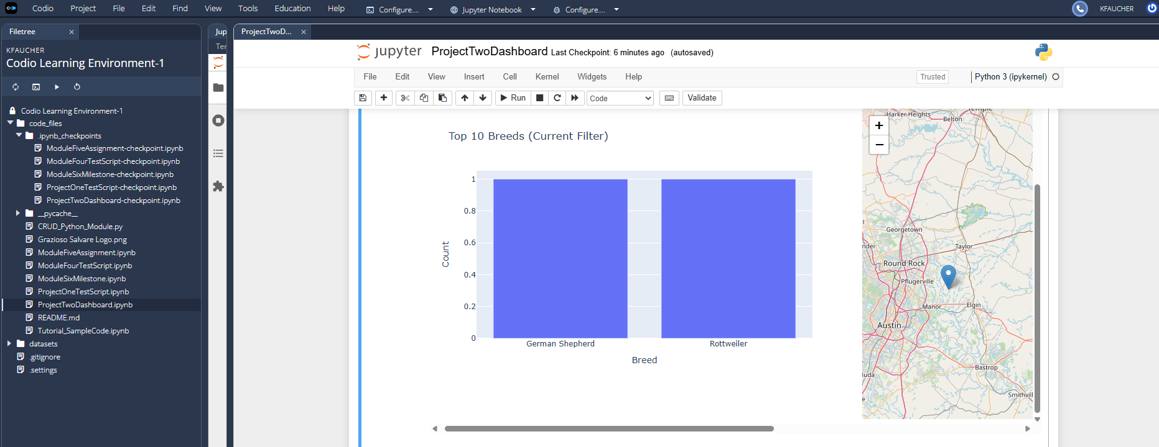
This screenshot verifies the Disaster or Individual Tracking filter. The data table displays only matching animals, the breed chart updates to reflect the filtered results, and the map highlights the appropriate geolocation. This confirms full end-to-end functionality for all required filters.
Tools and Technologies Used
- Python – Primary programming language
- MongoDB – NoSQL database used as the model component
- PyMongo – MongoDB driver for Python
- Dash & JupyterDash – Framework used to build the interactive dashboard
- Dash Leaflet – Used for geolocation mapping
- Plotly Express – Used for dynamic data visualizations
- Pandas – Data manipulation and formatting
- Jupyter Notebook – Development and deployment environment

Why MongoDB Was Used
MongoDB was selected because it is well-suited for handling large, semi-structured datasets like the Austin Animal Center Outcomes data. Its document-based structure allows flexible schema design and efficient querying. MongoDB integrates seamlessly with Python using PyMongo, making it an ideal choice for this application’s model layer.

Dash Framework (View & Controller)
Dash was used to implement both the view and controller components of the MVC architecture. Dash allows interactive components such as radio buttons, tables, charts, and maps to communicate through callback functions. These callbacks act as the controller, responding to user input and retrieving filtered data from MongoDB through the CRUD module.
Steps Taken to Complete the Project
- Developed and tested CRUD functionality for MongoDB in Python
- Connected the CRUD module to a Dash dashboard
- Created an interactive data table displaying unfiltered data
- Implemented rescue type filters using Dash radio buttons
- Added a geolocation map that updates based on selected rows
- Added a breed frequency chart that updates dynamically
- Tested all dashboard features and captured screenshots
- Documented the project in this README
Challenges and Solutions
One challenge encountered was managing dynamic updates between the data table, charts, and map. This was resolved by carefully structuring Dash callback functions and ensuring consistent data formats using Pandas. Another challenge involved managing JupyterDash server ports, which was resolved by specifying alternative ports during development.
Resources
- MongoDB Documentation
- Dash by Plotly Documentation
- SNHU CS-340 Course Materials

